BÀI TẬP THỰC HÀNH XỬ LÝ TÍN HIỆU SỐ BUỔI 2

Bài 1:

Bài 2:

Bài 3:

Bài 4:

Bài 5:

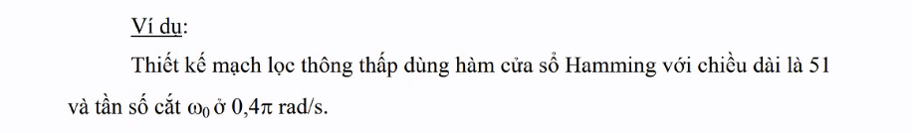

Bài tập 6:

Bài tập 7:

Bài tập 8: Thiết kế mạch lọc butter,cheby1,cheby2,ellip

\*Mạch lọc butter:

\*Mạch lọc cheby1:

\*Mạch lọc cheby2:

\*Mạch lọc ellip:

Bài tập 9:

Thiết kế mạch lọc butter,cheby1,cheby2,ellip

\*Mạch lọc butter:

Mạch lọc cheby1:

Mạch lọc cheby2:

Mạch lọc ellip:

Bài tập 10: Thiết kế mạch lọc cheby1, cheby2

\*Mạch lọc cheby1:

Mạch lọc cheby2:

